AUC and ROC Score:

For the performance measurement of the machine learning classification task, AUC and ROC Curve is of the most useful. AUC(Area Under Curve) -ROC (Receiver Operator Characteristics is the most important metric to determine the performance of the classification model.

AUC-ROC curve is the performance measurement of the classification problems at the various threshold. ROC is the probability curve meanwhile AUC measures the degree or measure of separability. In our datasets it tells how our made models is good at predicting the fraudulent and non-fraudulent transactions. Higher the AUC , the better is the model at distinguishing fraudulent and the non-fraudulent transactions. For plotting the ROC Curve, the two parameters have to be plotted which are:

* True Positive Rate
* False Positive Rate

True Positive Rate

True positive rate also the recall rate is defined as follows;

TPR = $\frac{TP}{TP+FN }$

False Positive Rate

False Positive Rate is defined as:

FPR = $\frac{FP}{TN+FP }$

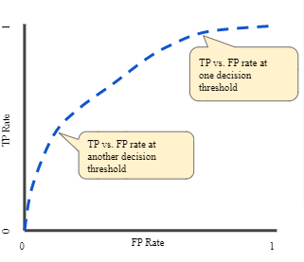

AUC (Area Under the Curve)

References:

<https://towardsdatascience.com/understanding-auc-roc-curve-68b2303cc9c5>

<https://developers.google.com/machine-learning/crash-course/classification/roc-and-auc>